Analysis of SaxStat_V02_AD5761_ESP32ADC_Test.ino (Firmware)
Overview
This firmware uses the AD5761 DAC to generate the voltage ramp and reads ADC data from GPIO34, sending it back to the GUI via serial.
Section-by-Section Breakdown
- Includes and Definitions:
  - Includes <SPI.h> and defines pins (SCK_PIN, MOSI_PIN, CS_PIN, ADC_PIN) and AD5761 commands (CMD_WR_CTRL_REG, etc.).
  - Defines MIN_DAC_CODE = 15934 (-1.5V) and MAX_DAC_CODE = 49602 (+1.5V) with STEP_SIZE = 256.
  - Observation: The DAC range is set to ±1.5V, which might conflict with the GUI’s -1V to +1V range unless mapped correctly.
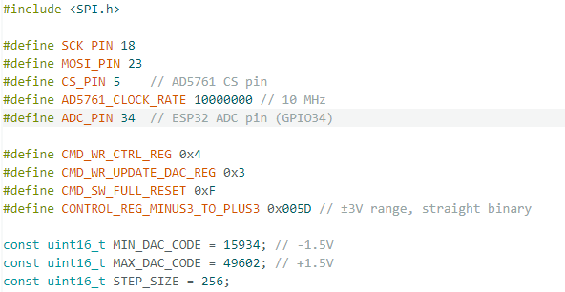
- SPI and DAC Write Function (ad5761_write):
  - Writes 16-bit data to the AD5761 via SPI in MODE2.
  - Observation: No issues; matches the hardware setup.
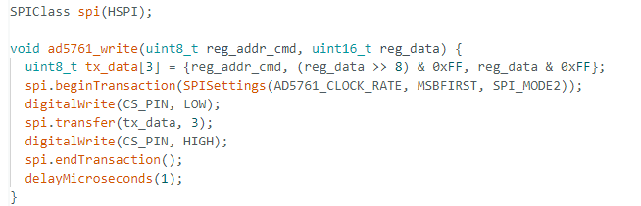
- Voltage Mapping Function (mapVoltageToDAC):
  - Maps a voltage (-1.5V to +1.5V) to a DAC code (15934 to 49602).
  - Observation: This function assumes the full ±1.5V range. If the GUI sends -1V to +1V, it needs scaling, but the function doesn’t adjust for dynamic ranges.
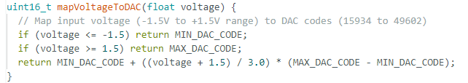
- Setup (setup):
  - Initializes serial at 115200 baud, SPI, and sets the DAC to 0V (32768).
  - Observation: The initial DAC value is set, but no parameter initialization occurs here.
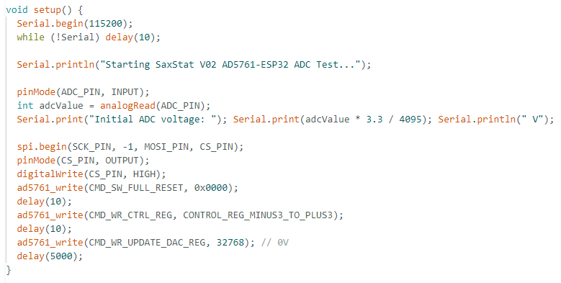
- Loop (loop):
  - Serial Input Handling:
    - Reads serial data into inputBuffer, parsing START:, SET_DAC:, or STOP commands.
    - For START:, extracts startVoltage, endVoltage, scanRate, and cycles, logging them.
    - Observation: Parsing logic is correct, but startVoltage and endVoltage are used directly without validating against the ±1.5V range.
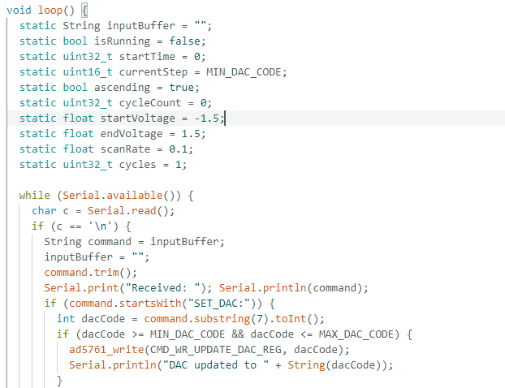
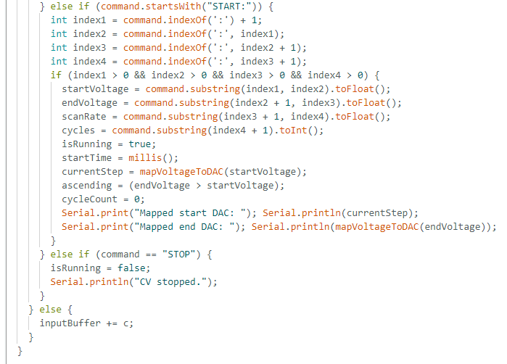
  - CV Execution:
    - Calculates voltageRange = abs(endVoltage - startVoltage) and halfCycleTime = voltageRange / scanRate.
    - Computes stepDelay based on (halfCycleTime * 1000) / ((MAX_DAC_CODE - MIN_DAC_CODE) / STEP_SIZE).
    - Uses a triangular waveform with currentStep incrementing/decrementing by STEP_SIZE, targeting mapVoltageToDAC(ascending ? endVoltage : startVoltage).
    - Increments cycleCount on reverse completion, stopping when cycleCount >= cycles.
    - Observation:
      - stepDelay uses the full DAC range (49602 - 15934), which may not match the GUI’s voltage range, potentially skewing the scan rate.
      - mapVoltageToDAC maps to ±1.5V, so if endVoltage is +1V, it caps at +1.5V, possibly causing a mismatch.
      - The loop structure should support multiple cycles, but if stepDelay or STEP_SIZE is misaligned, it might complete prematurely.
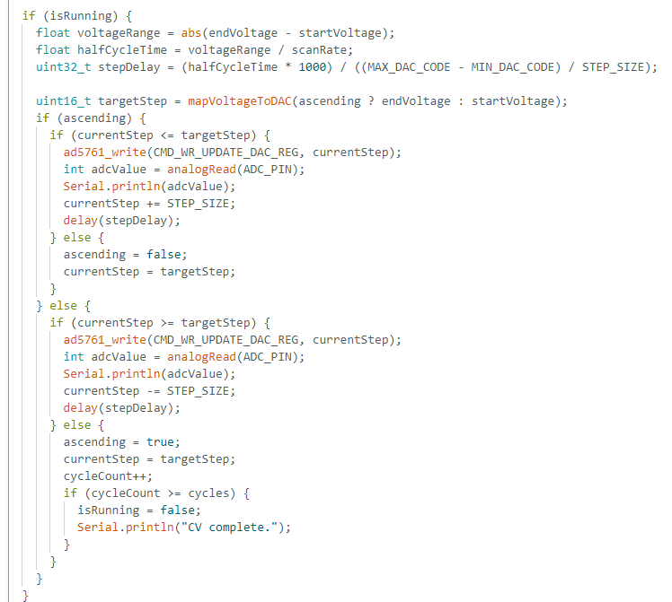
Key Insights:
  - The firmware uses the GUI’s startVoltage and endVoltage for voltageRange, which is correct, but mapVoltageToDAC and stepDelay are based on the ±1.5V DAC range, not the dynamic range. This could cause the ramp to deviate from the intended -1V to +1V.
  - The cycles parameter is respected, but the single-cycle display might indicate isRunning being reset or data not accumulating correctly.

